1. the sign in page: We will have to add a sign up option and a terms & conditions option.

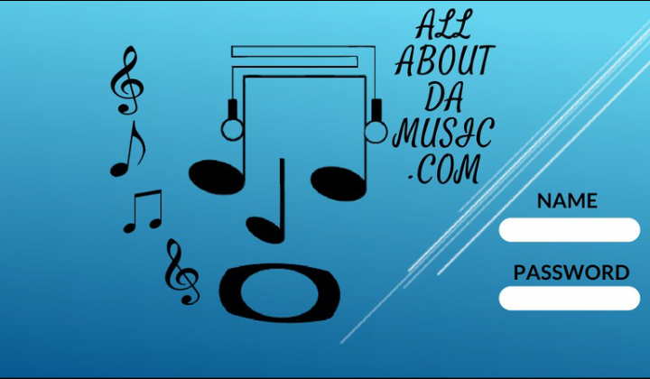20180607_014901.png

2. The sign up page for each registered user will be for basic information. Name, gender, email, genre of music, Location

3. The terms & conditions page: We are writing up the plan now explaining the monthly fees, transaction fees etc. I will be sending you the completed terms & condition in the next couple days.

4. The My Account page will be where the registered users can build, change, and add to their personalized profile pages. Manage their funds, manage their products they want to sell on site, and manage their content (music audio/videos)

5. The search bar icons should be: (Home, Search Talent, Search Jobs, Post Jobs, My Profile, My Account, Log Out)

6. I would like the (Home) and (About Us) page to be all in one, serving as the personalized profile page for allaboutdamusic.com. This way every registered user will automatically be following us. We will display our bio and contact info from here, also we will display spotlight artists and advertise for different talents from this page.

#6 Continued: Our Bio: Allaboutdamusic.com, is a branch of Live This Moment Publishing LLC., which was created by a team of music executives, producers, and artists who have over 15 years of experience in the music industry. Allaboutdamusic.com provides a platform for all talent in any category of music to bring their brand to the music world. Doing music no longer has to be a dream for you, it can be your career, because on this website you can search available jobs in the music world, apply for them, get hired, and get paid for your talent. All while you manage your brand, network & grow relationships with other brands, AND SO MUCH MORE!!! So now that you are truly a part of the music industry, congratulations! Have fun! Be smart! Do business! And ENJOY!!! "Live This Moment" "Bring your Brand to Life" "Make your Dreams a Reality"

L

Contact Info: Business Line: (727) 304-5595 Email: allaboutdamusicllc@gmail.com